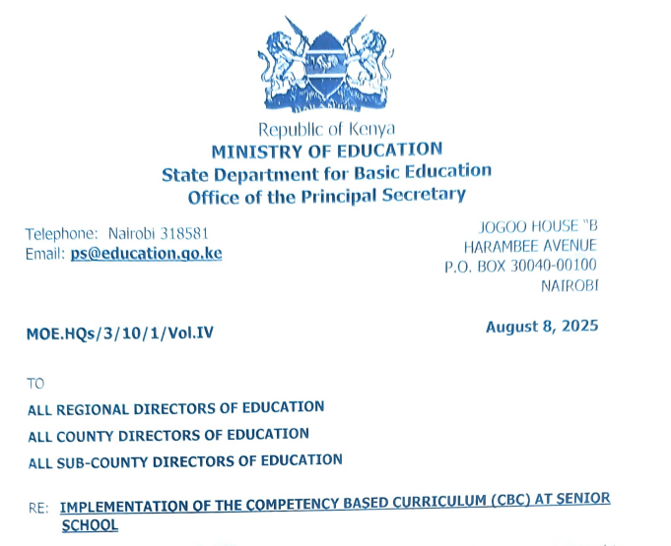
MOE.HQs/3/10/1/Vol.1V
August 8, 2025
TO
ALL REGIONAL DIRECTORS OF EDUCATION
ALL COUNTY DIRECTORS OF EDUCATION
ALL SUB-COUNTY DIRECTORS OF EDUCATION
RE: IMPLEMENTATION OF THE COMPETENCY-BASED CURRICULUM (CBC) AT SENIOR SCHOOL
As you are aware, the first cohort of the Competency-Based Education learners is expected to join Senior School in January 2026.
Senior School is the fourth (4th) level of Basic Education in the Competency Based Curriculum (CBC) coming after the Pre-Primary School (PPI and PP2), Primary School (Grades 1 to 6) and Junior School (Grades 7 to 9) levels.
The subjects at Senior School are classified according to three pathways, namely:- Science, Technology, Engineering and Mathematics (STEM), Arts and Sports Science and Social Science.
The essence of Senior School is to offer learners a pre-tertiary/ pre-university/ pre-career experience during which the learners have an opportunity to choose subjects from the pathways where they have demonstrated interest and/or potential at the earlier levels.
Senior School (Grades 10 to 12) comprises three years of education for learners generally in the age bracket of Fifteen (15) to Seventeen (17) years, with the learners completing this level expected to demonstrate the CBC vision of being engaged, empowered and ethical citizens ready to participate in the socio-economic development of the nation or proceed to further education.
At this level, learners shall take Seven (7) subjects as recommended by the Presidential Working Party on Educational Reforms (PWPER, 2023).
These shall comprise of four compulsory subjects namely:
- English,
- Kiswahili,
- Core Mathematics / Essential Mathematics
- Community Service Learning (CSL)
For clarity, all the learners shall take English, Kiswahili and Community Service Learning (CSC).
Learners pursuing the STEM pathway shall take Core Mathematics while those who shall have chosen any of the other two pathways will take Essential Mathematics.
If a learner who is not pursuing the STEM pathway opts to take Core Mathematics, they should be allowed to do so depending on their Junior School assessment results.
In addition to the compulsory learning areas, the learner will select three more subjects.
It is advised that a learner takes at least two subjects from the chosen pathway.
This means that a learner may take up to three more subjects from the chosen pathway or take two subjects from the chosen pathway and one subject from another pathway.
However, it should be anticipated that a situation may arise where a learner’s career choice requires that they take one subject in each pathway. Such a situation should he permitted.
The choices of subjects shall be guided by the learner’s anticipated career, aptitude, interest and personality with guidance by the leadership of the Senior School.
Table 1 below provides a list of all the subjects on offer at Senior School under the CBC, for which curriculum designs have been developed by the Kenya Institute of Curriculum Development (KICD).
Table 1: List of subjects at Senior School Grades 10, 11 and 12.
Compulsory Subjects | Arts & Sports Science | Social Sciences | Science, Technology,  Engineering &  Mathematics STEM
1. English  2. Kiswahili/KSL  3. Core Mathematics/  Essential Mathematics  4. Community Service Learning (CSL) | 1. Sports and Recreation  2. Music and Dance  3. Theatre and Film  4. Fine Arts | 1. Literature in English  2. Indigenous Languages  3. Fasihi ya Kiswahili  4. Sign Language  5. Arabic  6. French  7. German  8. Mandarin Chinese  9. Christian Religious  Education  10. Islamic Religious  Education  11. Hindu Religious  Education  12. Business Studies  13. History and Citizenship  14. Geography | 1. Biology  2. Chemistry  3. Physics  4. General Science  5. Agriculture  6. Computer Studies  7. Home Science  8. Aviation  9. Building Construction  10. Electricity  11. Metalwork  12. Power Mechanics  13. Woodwork  14. Media Technology  15. Marine and Fisheries Technology
Note:
a) Physical Education (PE) and Information Communication and Technology (ICT) will be offered to all learners to facilitate learning and acquisition of life skills.
b) Every school shall offer Pastoral/Religious Programme of Instruction (P/RPI) to enhance moral, spiritual and character development of the learners.
NO school should force learners to participate in religious rites and activities that are contrary to their beliefs as per Circular Ref No: MOE.HQs/3/10/18 dated 4th March, 2022.
c ) Table 2, below provides guidelines on distribution of lessons at Senior School.
Table 2. Lesson distribution at senior school
Subjects | No. of lessons per week (40 minutes per lesson)
1. English | 5
2. Kiswahili | 5
3. Core Mathematics Essential Mathematics | 5
4. Community Service Learning (CSL) | 3
Effective Subjects
5. Optional 1 | 5
6. Optional 2 | 5
7. Optional 3 | 5
* Physical Education | 3
* ICT Skills | 2
* Learner Personal/ Group Study | 1
* Pastoral/ Religious Programme Instruction | 1
Total Number of Lessons | 40
You are required to bring this information to the attention of all Quality Assurance & Standards Officers and Principals of Senior schools within your area of jurisdiction and, ensure this directive is implemented.
By a copy of this circular, the Departments of TVET and Higher Education are requested to review and align their courses in preparation for the first cohort of CBE students who are expected to join tertiary education in the year 2029.
PROF. AMB. JULIUS BITOK, CBS
PRINCIPAL SECRETARY

